**File Handling in C#**

1. **Log File Analysis**
   * **Scenario**: Analyze log files to identify and summarize occurrences of a specific error.
   * **Task**: Write a C# program to read log files for the past week, count occurrences of the error "Database Connection Failed", and write a summary report.
   * **Expected Input**: Log files like log_2024-08-10.txt, each containing lines like:

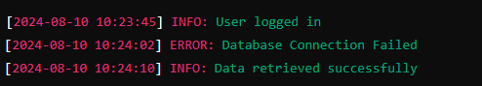

* + **Expected Output**: A summary report file (error_summary.txt) with content like:

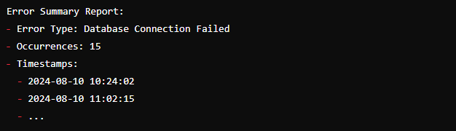

1. **Data Migration**
   * **Scenario**: Migrate data from a text file to a SQL/EXCEL/CSV database.
   * **Task**: Develop a C# program to read a pipe-delimited text file and insert records into a SQL database table.
   * **Expected Input**: A text file customers.txt with content like:



* + **Expected Output**: Records inserted into the database table Customers:

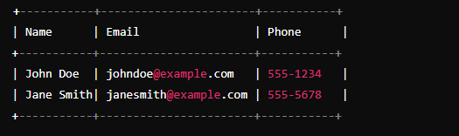

1. **Configuration Management**
   * **Scenario**: Manage configuration settings stored in different file formats.
   * **Task**: Create a C# utility that updates a specific setting in JSON, XML, and plain text configuration files.
   * **Expected Input**: Files like appsettings.json:

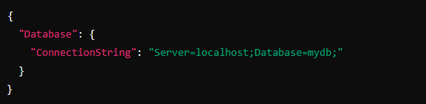

**and** config.xml:

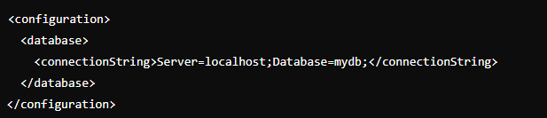

**Expected Output:** Updated configuration files with the connection string changed to Server=prodserver;Database=mydb;.

**Regular Expressions (Regex)**

1. **Data Validation for User Input**
   * **Scenario**: Validate user input for email addresses and phone numbers.
   * **Task**: Implement regex validation for emails and phone numbers.
   * **Expected Input**: User input such as user@example.com and +1-555-123-4567.
   * **Expected Output**:
     + For email: Validation result as True.
     + For phone: Validation result as True.
2. **Web Scraping for Market Analysis**
   * **Scenario**: Extract product prices from HTML pages.
   * **Task**: Write a regex-based C# program to scrape prices from e-commerce HTML pages.Use a html for input like sample.html
   * **Expected Input**: HTML snippet:

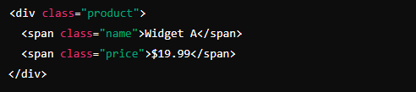

**Expected Output**:



1. **Log File Redaction**
   * **Scenario**: Redact sensitive information from log files.
   * **Task**: Develop a regex-based tool to redact credit card numbers.
   * **Expected Input**: Log file entry:
   * 
   * **Expected Output**: Redacted log file entry:
   * 

**Introduction to LINQ**

1. **Customer Data Aggregation**
   * **Scenario**: Aggregate customer data from multiple sources.
   * **Task**: Use LINQ to generate a unified customer profile.
   * **Expected Input**:
     + Sales table:
     + 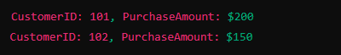
     + SupportTickets table
     + 
     + **Expected Output**:
     + 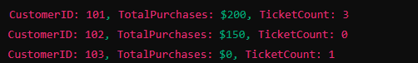
2. **Dynamic Reporting System**
   * **Scenario**: Create a dynamic reporting system.
   * **Task**: Implement LINQ queries to allow users to filter and sort sales data.
   * **Expected Input**:
     + Sales data:
     + 
     + Expected Output:
     + 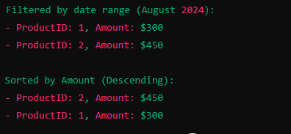
3. **Data Transformation and Cleanup**
   * **Scenario**: Prepare data for machine learning analysis by cleaning and transforming it.
   * **Task**: Use LINQ to remove duplicates, fill missing values, and standardize formats.
   * **Expected Input**:
     + Raw dataset:
     + 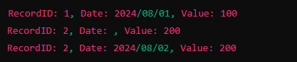
     + Expected Output:
     + 